PROJECT DEMONSTRATION
DEMONSTRATION STEPS:
1. Login to ServiceNow Instance
First, log in to the ServiceNow platform using valid administrator credentials. After logging in, the dashboard of the ServiceNow instance appears, where different modules and tables can be accessed for performing system operations.
2. Upload CSV File into Data Source
Create a Data Source in ServiceNow and upload the CSV file containing user information such as Name, Email, and Department. The CSV file acts as the external data source that will be imported into the ServiceNow system.
3. Run the Import Set
Once the CSV file is uploaded, an Import Set Table is automatically created. The data from the CSV file is temporarily stored in this table before being transferred to the target table.
4. Execute Transform Map
A Transform Map is configured to map the fields from the Import Set Table to the target table (User Table). During this step, field mapping is defined so that the data from the CSV file correctly matches the corresponding fields in the target table.
5. Verify Records in the Target Table
After running the transform map, the system imports the records into the target table. The administrator verifies whether the data has been successfully imported and checks if the fields such as name, email, and department are correctly populated.
6. Open Incident Form
Next, the Incident form is opened in ServiceNow to demonstrate the relationship between user records and other tables in the system.
7. Select a User in the Assigned To Field
In the Incident form, a user is selected in the Assigned To field. This field references the User table that was populated using the Import Set process.

8. Observe Automatic Field Population using Dot Walking
When the user is selected, related fields such as Department and Email are automatically populated. This happens through the Dot Walking feature, which allows the system to retrieve related data from referenced tables without manually entering the information.

RESULT
The demonstration confirms that the system successfully imports user data from a CSV file into the ServiceNow database using Import Sets and Transform Maps. Additionally, the Dot Walking feature automatically retrieves related information from reference tables. This improves data consistency, reduces manual work, and ensures accurate relationship mapping between tables.

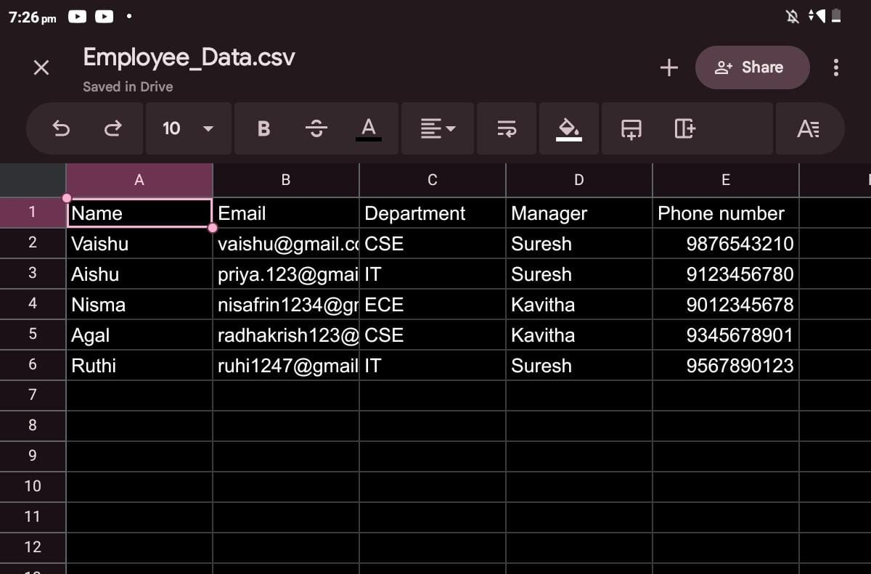
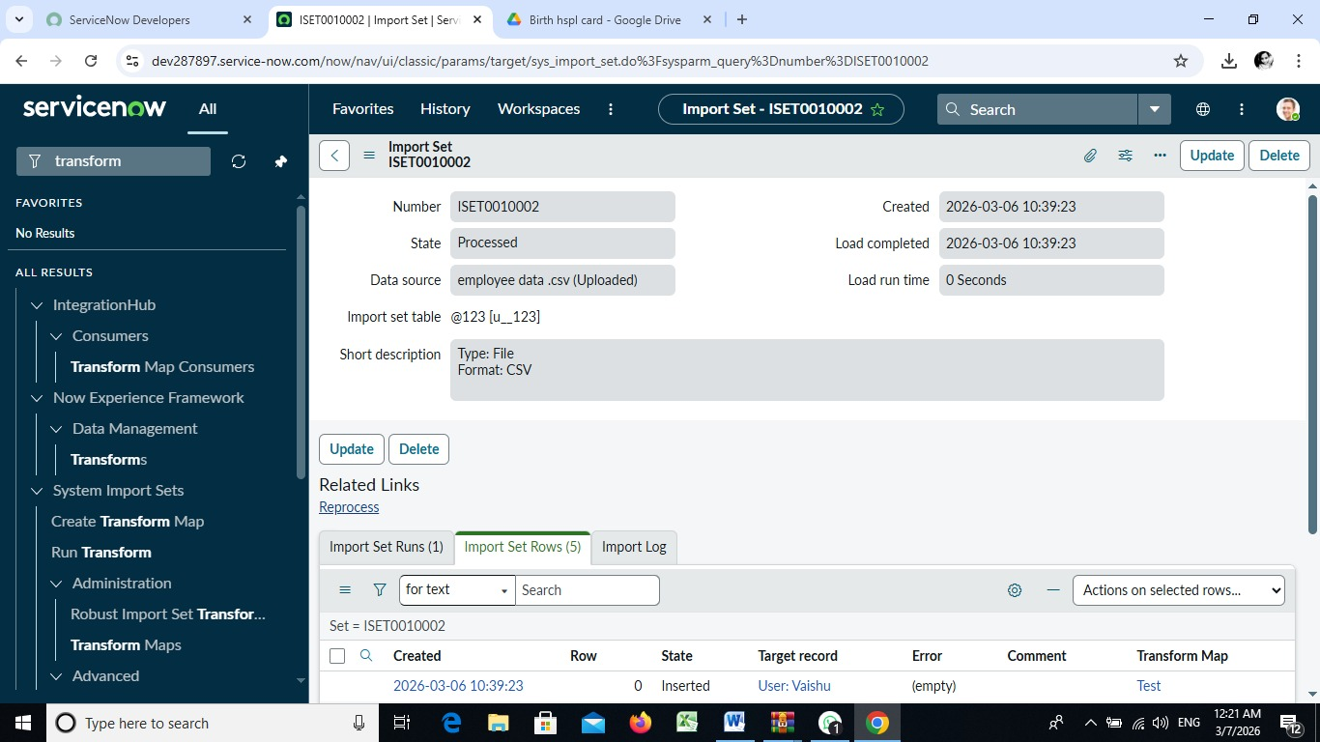
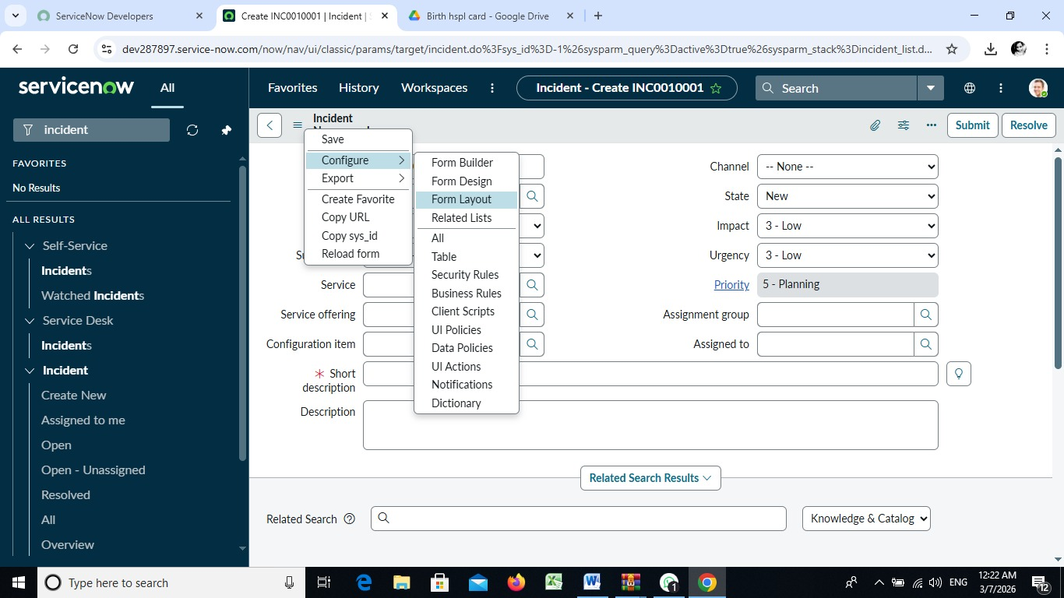

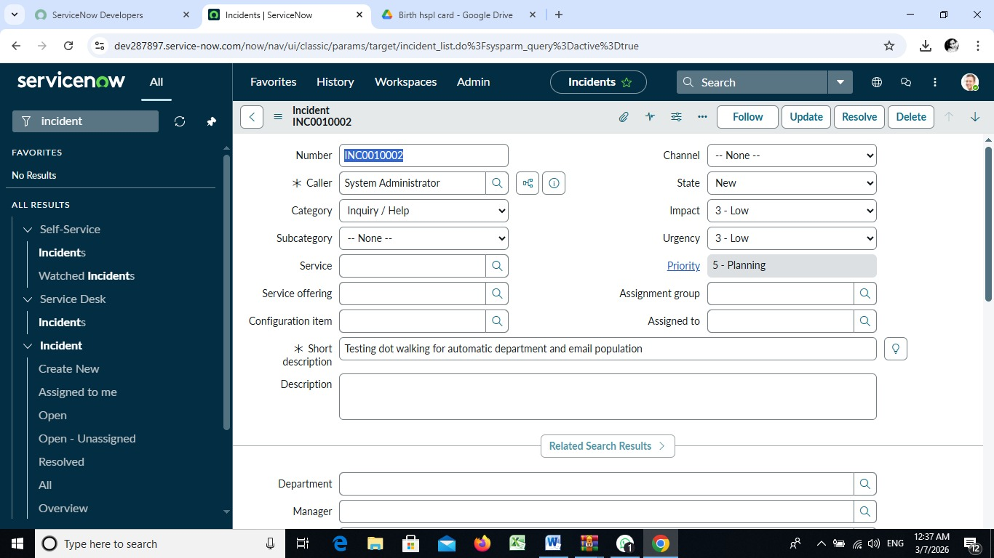
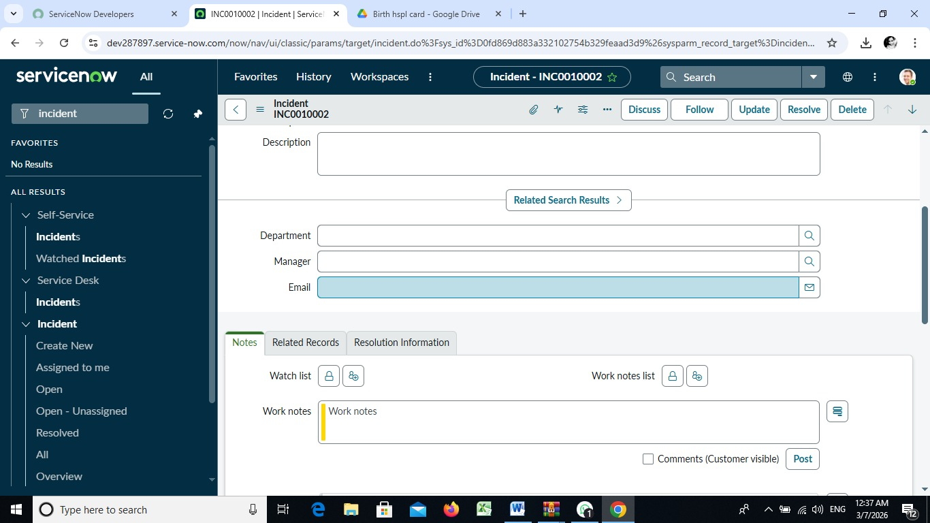

CONCLUSION
This project demonstrates the practical implementation of automated data import and relationship mapping in ServiceNow. By using Import Sets, Transform Maps, and Dot Walking, organizations can efficiently manage large volumes of data while maintaining relationships between different tables. The automation reduces manual data entry, improves accuracy, and enhances overall system efficiency in managing IT service information.

